ANSWER KEY
NO |  |  | QUESTIONS |  | MARKS
SECTION A
1 |  |  | - It is a decomposition reaction and endothermic in nature.
2 |  |  | d) Behind the mirror |  | 1
3 |  |  | - Lenticels |  | 1
4 |  |  |  | Assertion is true but Reason is false | 1
5 |  |  |  | Assertion is true but Reason is false | 1
6 |  |  |  | Both (A) and (R) are true and (R)is the correct explanation of assertion. | 1
SECTION B
7 | - BaSO₄  - Pb(NO₃ )₂(aq)+2 KI(aq)→ PbI₂(s) + 2KNO₃(aq)  - HCl + NaOH → NaCl + H₂O |  |  |  | 1  1  1
8 | - Concave mirror, real and inverted  - u= -12 cm  - m=-4 |  |  |  | 1  1  1
9 | - The gills lie behind and to the side of the mouth cavity  - Water taken in continuously through the mouth passes backward between the gill bars and over the gill filaments, where the exchange of gases takes place.  - The word ‘teleost’ mentioned for the fishes which have gill cover to protect the gills. |  |  |  | 1  1  1
SECTION C
10 |  |  |  | heat  2Cu + O₂ → 2CuO  Copper oxide on heating with hydrogen will change back to reddish brown copper metal.  heat  CuO + H₂ → Cu + H₂O  OR  The blue coloured solution will become pale green.  Reddish brown deposit on iron nail.  Fe + CuSO₄ → FeSO₄ + Cu | ½  ½  1  ½  ½  1
11 |  |  |  | 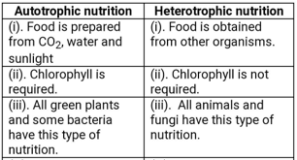  OR  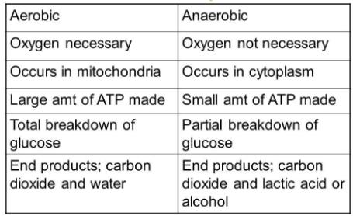 | (any two appropriate differences) (1 + 1= 2)
12 |  |  |  | Laws of reflection of light are:  i. The angle of incidence is equal to the angle of reflection.  ii. The incident ray, the normal to the reflecting surface at the point of incidence and reflected ray from that point, all lies in the same plane. | 2
SECTION D
13 | 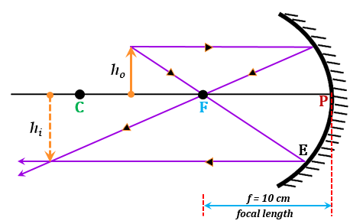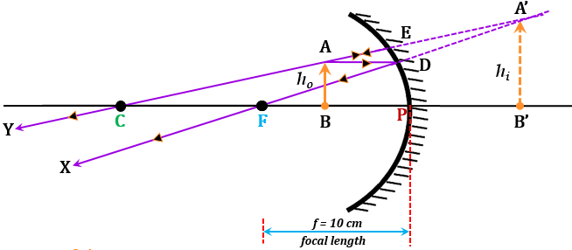  (b) distance between the object and image=0.5+0.5=1m  OR  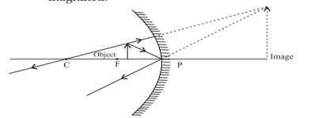  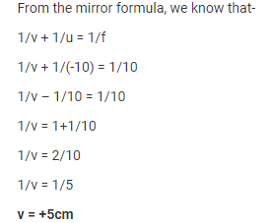 |  |  |  | 1  1  1  1  1  1
14 |  | One chemical reaction each for change in colour, change in temperature and formation of precipitate. |  |  | 1+1+1
15 |  | 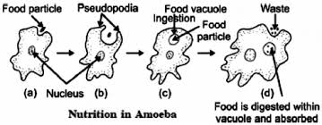  OR  (i)Draw the pathways of breakdown of glucose in the absence of oxygen and in the presence of oxygen only.  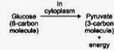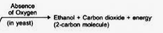  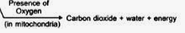  (ii)  Ans – Due to the build-up of Lactic acid in the muscles |  |  | (correct diagram 1 mark)  Brief description of holozoic nutrition (2marks)  (1+2=3 marks)  (1 + 1 = 2marks)  (1 mark) (2+1 = 3marks)

